# CS 255 System Design Document Template

## UML Diagrams

Justine Kummer

### UML Use Case Diagram

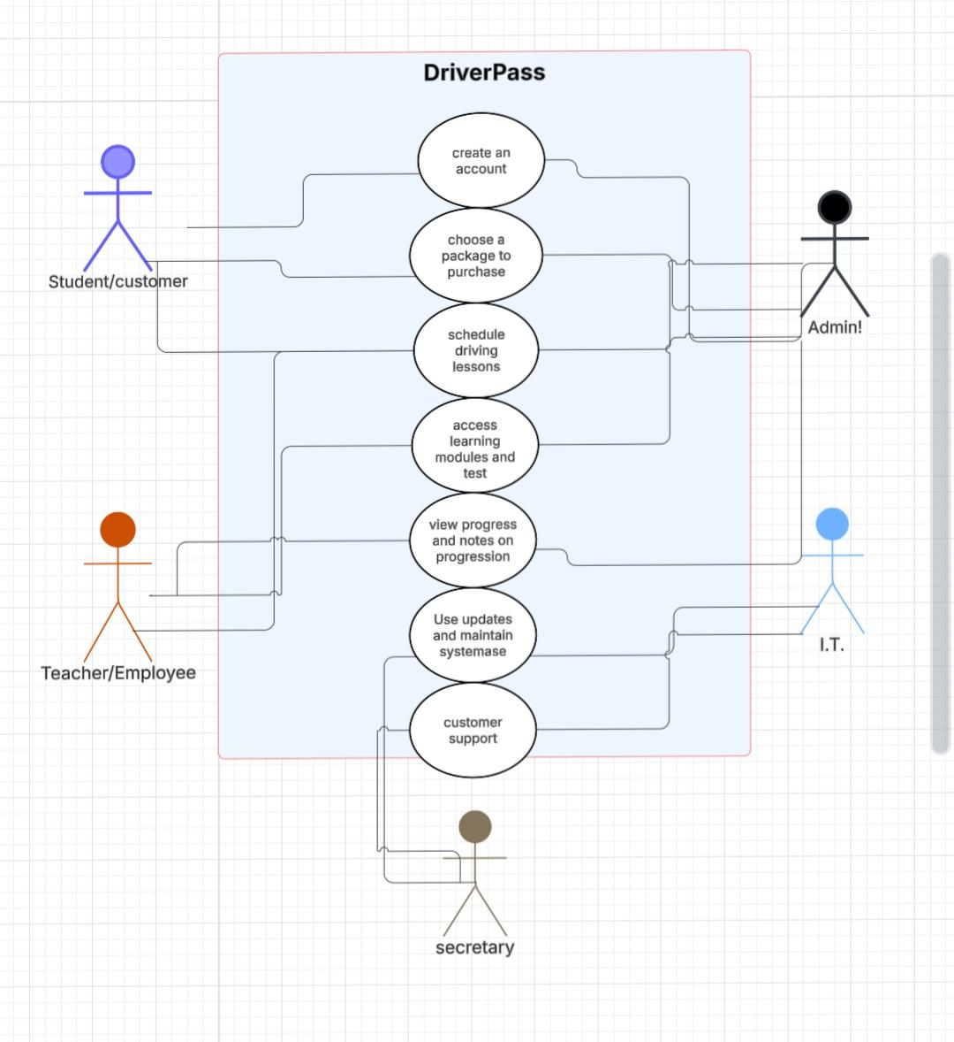

### UML Activity Diagrams

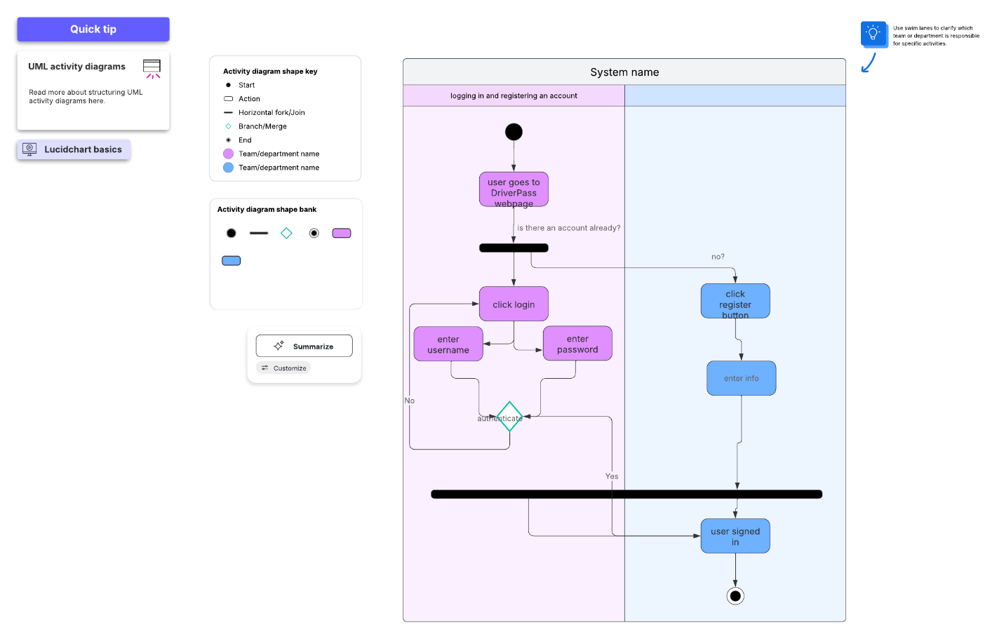

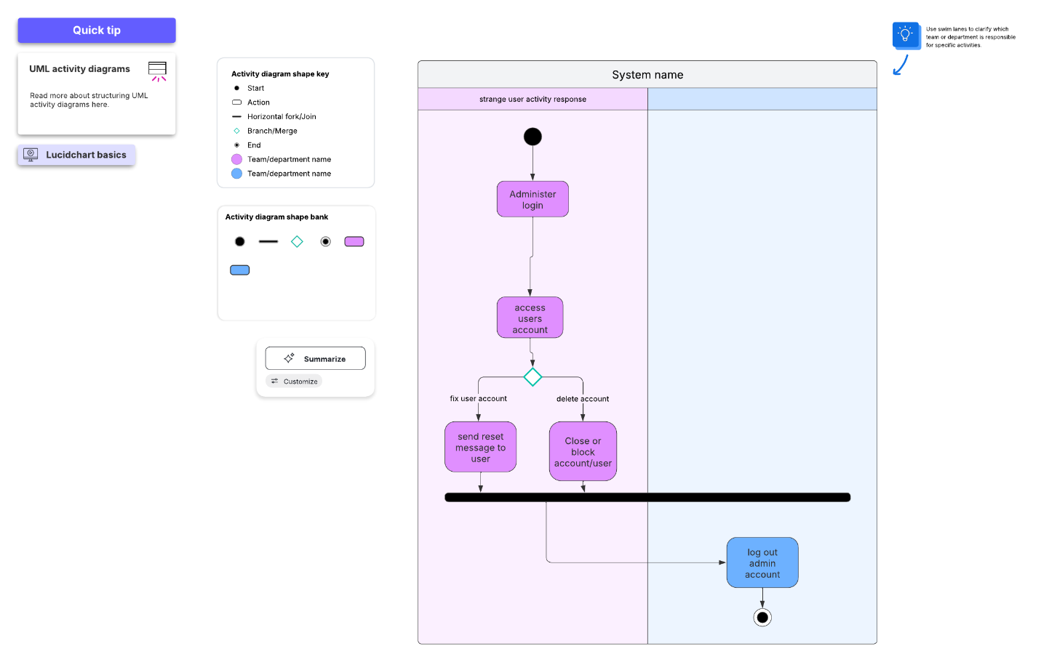

### UML Sequence Diagram

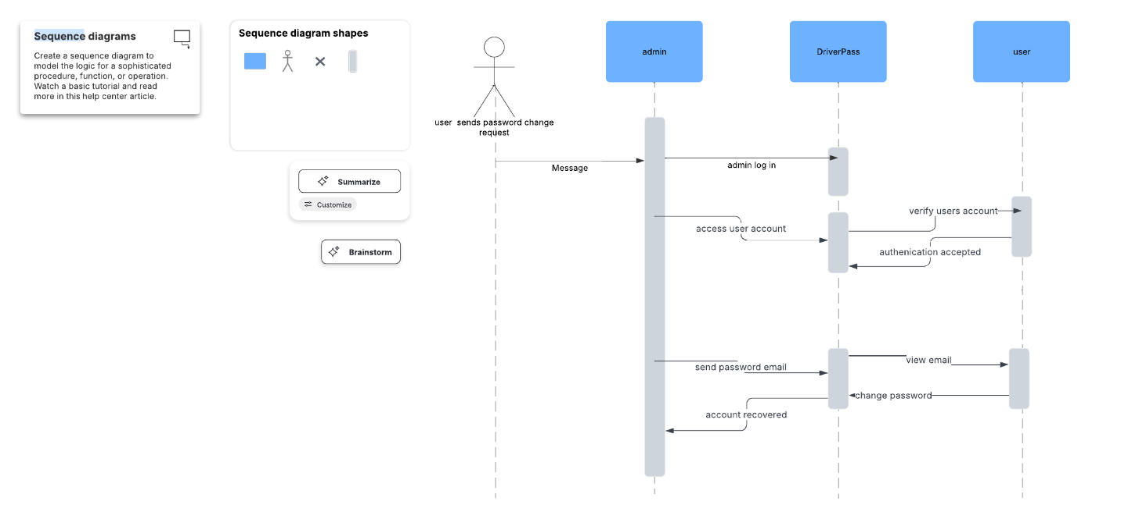

### UML Class Diagram

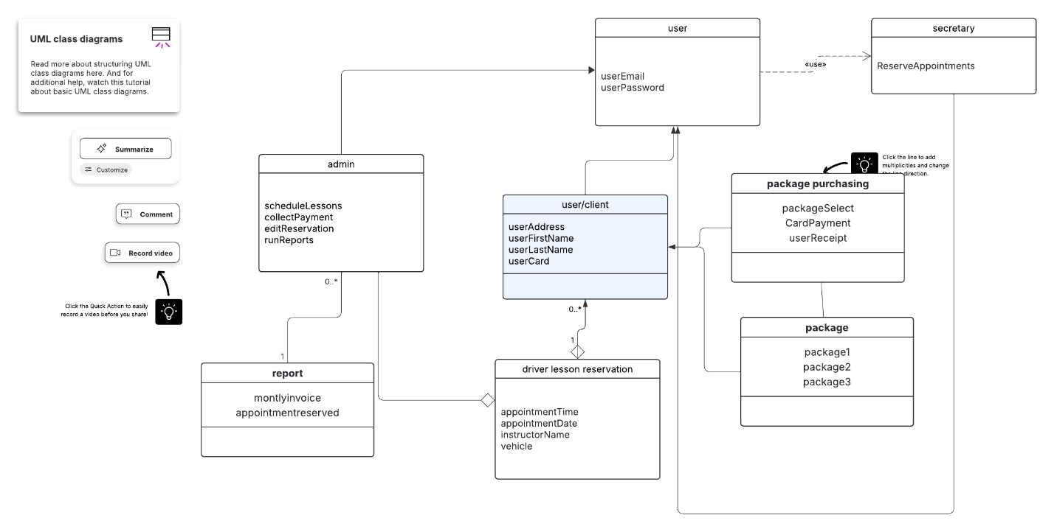

## Technical Requirements

A cloud-based server is recommended, since it is cost-effective and can be expanded easily as needed. The DMV should send updates when new rules are implemented. The web portal should also be accessible to as many devices as possible. Most common are Windows, Mac and mobile OS systems. Security software should be used. A system for storing individual usernames and unique passwords should be used as well as encryption. Users will need a device with a browser and internet connection. Admin, users and other roles should have a set of different permissions available to each. Suspicious activity should trigger a lockout and notification to users.